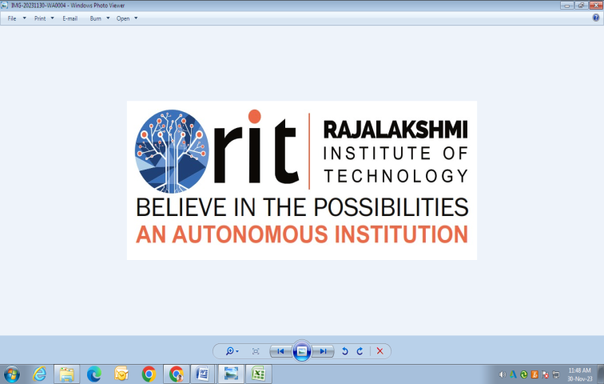
RAJALAKSHMI INSTITUTE OF TECHNOLOGY
(An Autonomous Institution, Affiliated to Anna University, Chennai)

DEPARTMENT OF ARTIFICIAL INTELLIGENCE AND DATA SCIENCE
ACADEMIC YEAR 2025 - 2026
SEMESTER III
ARTIFICIAL INTELLIGENCE LABORATORY
MINI PROJECT REPORT

REGISTER NUMBER | 2117240070277
NAME | SANTHOSH KUMAR S
PROJECT TITLE | TIC-TAC-TOE USING MINIMAX WITH ALPHA-BETA PRUNING
DATE OF SUBMISSION
FACULTY IN-CHARGE | BHAVANI M

Signature of Faculty In-charge

INTRODUCTION
• Objective: Build an intelligent Tic-Tac-Toe game that plays perfectly.
• Tools Used: Python, Pygame.
• Key Concept: MiniMax algorithm with Alpha-Beta pruning.
• Highlights:
- Real-time GUI interface with animations
- Smart AI with optimized decision making
- Displays statistics like nodes, prune count & time

PROBLEM STATEMENT
The objective of this project is to design and develop an intelligent Tic-Tac-Toe game using the MiniMax algorithm with Alpha-Beta pruning, where the computer plays as an optimal opponent against a human user. The system must evaluate all possible moves, predict the opponent’s responses, and always select the best strategy to either win or force a draw. The project includes a graphical user interface built using Python and Pygame, allowing interactive gameplay, real-time move calculations, and display of performance metrics such as nodes evaluated, pruned nodes, and computation time. The goal is to demonstrate the application of artificial intelligence search algorithms in game decision-making and optimize the execution through pruning techniques.

GOAL
The goal of this project is to develop an intelligent Tic-Tac-Toe system that can consistently play optimally against a human player by implementing the MiniMax algorithm with Alpha-Beta pruning. The system aims to accurately evaluate all potential game states, make the best possible move at each turn, and either win or force a draw every time. Additionally, the project seeks to provide an interactive and user-friendly graphical interface using Python and Pygame, while visualizing AI performance metrics such as search nodes, pruning count, and computation time.

THEORETICAL BACKGROUND
Artificial Intelligence (AI) enables machines to simulate human intelligence and decision-making. One of the classical problem-solving areas in AI is game playing, where algorithms evaluate possible moves and choose the most advantageous outcome. Tic-Tac-Toe is a fundamental two-player, zero-sum strategy game often used as a benchmark for understanding AI search algorithms due to its limited state space and deterministic nature.
This project uses the MiniMax algorithm, a recursive decision-making technique widely applied in turn-based games. MiniMax operates by exploring all possible future game states and selecting the move that maximizes the AI's chance of winning while minimizing the human player’s chances. It assumes that both players play optimally, making it a perfect-play algorithm. However, MiniMax can be computationally expensive due to its exhaustive search of the game tree.
To optimize MiniMax, Alpha-Beta Pruning is applied. Alpha-Beta Pruning eliminates branches in the decision tree that do not influence the final result, thereby reducing the number of evaluated nodes without affecting accuracy. This significantly improves performance and reduces computation time.
Additionally, a Graphical User Interface (GUI) is implemented using Python's Pygame library, providing interactive gameplay and real-time visualization of AI decisions. The system also displays performance metrics including the number of evaluated nodes, pruned branches, and execution time. This combination of search algorithms and visualization demonstrates how AI techniques can be applied in real-time game environments and highlights the effectiveness of pruning in decision-making systems.

✅ KEY CONCEPTS
Artificial Intelligence & Game Theory
MiniMax Search Algorithm
Zero-sum Turn-based Game Strategy
Alpha-Beta Pruning for Optimization
GUI-based AI Interaction (Pygame)

ALGORITHM EXPLANATION WITH EXAMPLE

MiniMax Algorithm
MiniMax is a recursive algorithm used in decision-making and game theory to find the optimal move.
It assumes:
AI = Maximizer (tries to maximize score)
Human = Minimizer (tries to minimize score)
The algorithm simulates all possible moves, predicts opponent responses, and selects the move that leads to the best outcome.

Alpha-Beta Pruning
Alpha-Beta pruning improves MiniMax by cutting off branches that do not affect the final decision.
- Alpha (α) → Best value the maximizer currently can guarantee.
- Beta (β) → Best value the minimizer currently can guarantee.
If β ≤ α, further exploration of that branch is stopped (pruned), saving computation time.

MiniMax Steps (Tic-Tac-Toe)
- Check if the game has reached terminal state
  - AI wins → return +10
  - Human wins → return −10
  - Draw → return 0
- If it's AI's turn (Maximizer)
  - For each empty cell:
    - Simulate move
    - Recursively call MiniMax
    - Select the maximum score
- If it's Human's turn (Minimizer)
  - For each empty cell:
    - Simulate move
    - Recursively call MiniMax
    - Select the minimum score
- Return the best possible value

MiniMax returns values like:
Move | Score
(1,1) | +0 (draw)
(1,2) | −10 (loss)
(2,0) | +10 ✅ (win)
(2,1) | +0
(2,2) | +0

IMPLEMENTATION AND CODE
"""
Tic-Tac-Toe AI using MiniMax with Alpha-Beta Pruning
Enhanced GUI version using Pygame with animations
"""

import pygame
import math
import time
import sys

# Initialize Pygame
pygame.init()

# Constants
WIDTH, HEIGHT = 800, 900
BOARD_SIZE = 600
LINE_WIDTH = 15
CIRCLE_RADIUS = 80
CIRCLE_WIDTH = 15
CROSS_WIDTH = 25
SPACE = 55

# Colors
BG_COLOR = (28, 170, 156)
LINE_COLOR = (23, 145, 135)
CIRCLE_COLOR = (239, 231, 200)
CROSS_COLOR = (66, 66, 66)
TEXT_COLOR = (255, 255, 255)
BUTTON_COLOR = (52, 152, 219)
BUTTON_HOVER = (41, 128, 185)

# Setup display
screen = pygame.display.set_mode((WIDTH, HEIGHT))
pygame.display.set_caption('Tic-Tac-Toe AI - MiniMax with Alpha-Beta Pruning')
clock = pygame.time.Clock()

# Fonts
title_font = pygame.font.Font(None, 48)
stats_font = pygame.font.Font(None, 28)
button_font = pygame.font.Font(None, 32)

class TicTacToeGame:
"""Tic-Tac-Toe game with AI using MiniMax"""

def __init__(self):
"""Initialize game state"""
self.board = [[' ' for _ in range(3)] for _ in range(3)]
self.human = 'O'
self.ai = 'X'
self.game_over = False
self.winner = None

# Statistics
self.nodes_evaluated = 0
self.pruning_count = 0
self.time_taken = 0

# Score tracking
self.games_played = 0
self.human_wins = 0
self.ai_wins = 0
self.draws = 0

# Animation
self.ai_thinking = False
self.thinking_dots = 0
self.thinking_timer = 0

def draw_lines(self):
"""Draw the game board lines"""
# Vertical lines
pygame.draw.line(screen, LINE_COLOR, (200, 150), (200, 750), LINE_WIDTH)
pygame.draw.line(screen, LINE_COLOR, (400, 150), (400, 750), LINE_WIDTH)
# Horizontal lines
pygame.draw.line(screen, LINE_COLOR, (0, 350), (600, 350), LINE_WIDTH)
pygame.draw.line(screen, LINE_COLOR, (0, 550), (600, 550), LINE_WIDTH)

def draw_figures(self):
"""Draw X's and O's on the board"""
for row in range(3):
for col in range(3):
if self.board[row][col] == 'O':
self.draw_circle(row, col)
elif self.board[row][col] == 'X':
self.draw_cross(row, col)

def draw_circle(self, row, col):
"""Draw O (circle) at specified position"""
center_x = col * 200 + 100
center_y = row * 200 + 250
pygame.draw.circle(screen, CIRCLE_COLOR, (center_x, center_y), CIRCLE_RADIUS, CIRCLE_WIDTH)

def draw_cross(self, row, col):
"""Draw X (cross) at specified position"""
start_x = col * 200 + SPACE
start_y = row * 200 + 150 + SPACE
end_x = col * 200 + 200 - SPACE
end_y = row * 200 + 350 - SPACE

pygame.draw.line(screen, CROSS_COLOR, (start_x, start_y), (end_x, end_y), CROSS_WIDTH)
pygame.draw.line(screen, CROSS_COLOR, (end_x, start_y), (start_x, end_y), CROSS_WIDTH)

def evaluate(self):
"""Evaluate the board state"""
# Check rows
for row in self.board:
if row[0] == row[1] == row[2] != ' ':
return 10 if row[0] == self.ai else -10

# Check columns
for col in range(3):
if self.board[0][col] == self.board[1][col] == self.board[2][col] != ' ':
return 10 if self.board[0][col] == self.ai else -10

# Check diagonals
if self.board[0][0] == self.board[1][1] == self.board[2][2] != ' ':
return 10 if self.board[0][0] == self.ai else -10

if self.board[0][2] == self.board[1][1] == self.board[2][0] != ' ':
return 10 if self.board[0][2] == self.ai else -10

return 0

def is_moves_left(self):
"""Check if there are moves left"""
for row in self.board:
if ' ' in row:
return True
return False

def minimax(self, depth, is_max, alpha, beta):
"""MiniMax with Alpha-Beta pruning"""
self.nodes_evaluated += 1

score = self.evaluate()

if score == 10:
return score - depth
if score == -10:
return score + depth
if not self.is_moves_left():
return 0

if is_max:
best = -math.inf

for i in range(3):
for j in range(3):
if self.board[i][j] == ' ':
self.board[i][j] = self.ai
best = max(best, self.minimax(depth + 1, False, alpha, beta))
self.board[i][j] = ' '

alpha = max(alpha, best)
if beta <= alpha:
self.pruning_count += 1
break
if beta <= alpha:
break

return best
else:
best = math.inf

for i in range(3):
for j in range(3):
if self.board[i][j] == ' ':
self.board[i][j] = self.human
best = min(best, self.minimax(depth + 1, True, alpha, beta))
self.board[i][j] = ' '

beta = min(beta, best)
if beta <= alpha:
self.pruning_count += 1
break
if beta <= alpha:
break

return best

def find_best_move(self):
"""Find the best move for AI"""
self.nodes_evaluated = 0
self.pruning_count = 0

best_val = -math.inf
best_move = (-1, -1)

start_time = time.time()

for i in range(3):
for j in range(3):
if self.board[i][j] == ' ':
self.board[i][j] = self.ai
move_val = self.minimax(0, False, -math.inf, math.inf)
self.board[i][j] = ' '

if move_val > best_val:
best_move = (i, j)
best_val = move_val

self.time_taken = (time.time() - start_time) * 1000

return best_move

def check_winner(self):
"""Check if game has ended"""
score = self.evaluate()

if score == 10:
self.winner = 'AI'
self.ai_wins += 1
self.games_played += 1
self.game_over = True
return True
elif score == -10:
self.winner = 'Human'
self.human_wins += 1
self.games_played += 1
self.game_over = True
return True
elif not self.is_moves_left():
self.winner = 'Draw'
self.draws += 1
self.games_played += 1
self.game_over = True
return True

return False

def make_move(self, row, col):
"""Make a move at specified position"""
if self.board[row][col] == ' ' and not self.game_over:
self.board[row][col] = self.human
return True
return False

def ai_move(self):
"""Let AI make a move"""
self.ai_thinking = True
move = self.find_best_move()
if move != (-1, -1):
self.board[move[0]][move[1]] = self.ai
self.ai_thinking = False

def reset(self):
"""Reset the game"""
self.board = [[' ' for _ in range(3)] for _ in range(3)]
self.game_over = False
self.winner = None
self.nodes_evaluated = 0
self.pruning_count = 0
self.time_taken = 0

class Button:
"""Button class for UI controls"""

def __init__(self, x, y, width, height, text):
self.rect = pygame.Rect(x, y, width, height)
self.text = text
self.color = BUTTON_COLOR
self.hover = False

def draw(self, surface):
"""Draw the button"""
color = BUTTON_HOVER if self.hover else self.color
pygame.draw.rect(surface, color, self.rect, border_radius=10)
pygame.draw.rect(surface, TEXT_COLOR, self.rect, 3, border_radius=10)

text_surf = button_font.render(self.text, True, TEXT_COLOR)
text_rect = text_surf.get_rect(center=self.rect.center)
surface.blit(text_surf, text_rect)

def check_hover(self, pos):
"""Check if mouse is hovering over button"""
self.hover = self.rect.collidepoint(pos)

def is_clicked(self, pos):
"""Check if button is clicked"""
return self.rect.collidepoint(pos)

def draw_ui(game, buttons):
"""Draw the complete UI"""
screen.fill(BG_COLOR)

# Title
title_text = title_font.render('Tic-Tac-Toe AI', True, TEXT_COLOR)
screen.blit(title_text, (WIDTH // 2 - title_text.get_width() // 2, 20))

# Draw game board
game.draw_lines()
game.draw_figures()

# Statistics
if game.ai_thinking:
dots = '.' * (game.thinking_dots + 1)
stats_text = f"AI is thinking{dots}"
else:
stats_text = f"Nodes: {game.nodes_evaluated} | Pruned: {game.pruning_count} | Time: {game.time_taken:.2f}ms"

stats_surface = stats_font.render(stats_text, True, TEXT_COLOR)
screen.blit(stats_surface, (WIDTH // 2 - stats_surface.get_width() // 2, 770))

# Score
score_text = f"Games: {game.games_played} | You: {game.human_wins} | AI: {game.ai_wins} | Draws: {game.draws}"
score_surface = stats_font.render(score_text, True, TEXT_COLOR)
screen.blit(score_surface, (WIDTH // 2 - score_surface.get_width() // 2, 810))

# Draw buttons
for button in buttons:
button.draw(screen)

# Game over message
if game.game_over:
overlay = pygame.Surface((WIDTH, HEIGHT))
overlay.set_alpha(180)
overlay.fill((0, 0, 0))
screen.blit(overlay, (0, 0))

if game.winner == 'AI':
result_text = "AI WINS! 🤖"
elif game.winner == 'Human':
result_text = "YOU WIN! 🎉"
else:
result_text = "IT'S A DRAW! 🤝"

result_surface = title_font.render(result_text, True, TEXT_COLOR)
screen.blit(result_surface, (WIDTH // 2 - result_surface.get_width() // 2, HEIGHT // 2 - 50))

play_again_surface = stats_font.render('Click "New Game" to play again', True, TEXT_COLOR)
screen.blit(play_again_surface, (WIDTH // 2 - play_again_surface.get_width() // 2, HEIGHT // 2 + 20))

def get_cell_from_mouse(pos):
"""Convert mouse position to board cell"""
x, y = pos

if y < 150 or y > 750 or x > 600:
return None

row = (y - 150) // 200
col = x // 200

return (row, col)

def main():
"""Main game loop"""
game = TicTacToeGame()

# Create buttons
buttons = [
Button(620, 200, 160, 50, 'New Game'),
Button(620, 280, 160, 50, 'AI First'),
Button(620, 360, 160, 50, 'Reset Stats')
]

running = True

while running:
clock.tick(60)
mouse_pos = pygame.mouse.get_pos()

# Update thinking animation
if game.ai_thinking:
game.thinking_timer += 1
if game.thinking_timer >= 30:
game.thinking_dots = (game.thinking_dots + 1) % 3
game.thinking_timer = 0

# Event handling
for event in pygame.event.get():
if event.type == pygame.QUIT:
running = False

if event.type == pygame.MOUSEBUTTONDOWN:
# Check button clicks
if buttons[0].is_clicked(mouse_pos): # New Game
game.reset()
elif buttons[1].is_clicked(mouse_pos): # AI First
game.reset()
pygame.time.wait(500)
game.ai_move()
game.check_winner()
elif buttons[2].is_clicked(mouse_pos): # Reset Stats
game.games_played = 0
game.human_wins = 0
game.ai_wins = 0
game.draws = 0
game.reset()

# Check board clicks
else:
cell = get_cell_from_mouse(mouse_pos)
if cell and not game.game_over and not game.ai_thinking:
row, col = cell
if game.make_move(row, col):
if not game.check_winner():
pygame.time.wait(300)
game.ai_move()
game.check_winner()

# Update button hover states
for button in buttons:
button.check_hover(mouse_pos)

# Draw everything
draw_ui(game, buttons)
pygame.display.flip()

pygame.quit()
sys.exit()

if __name__ == "__main__":
main()

OUTPUT

Output 1: Game Interface Display
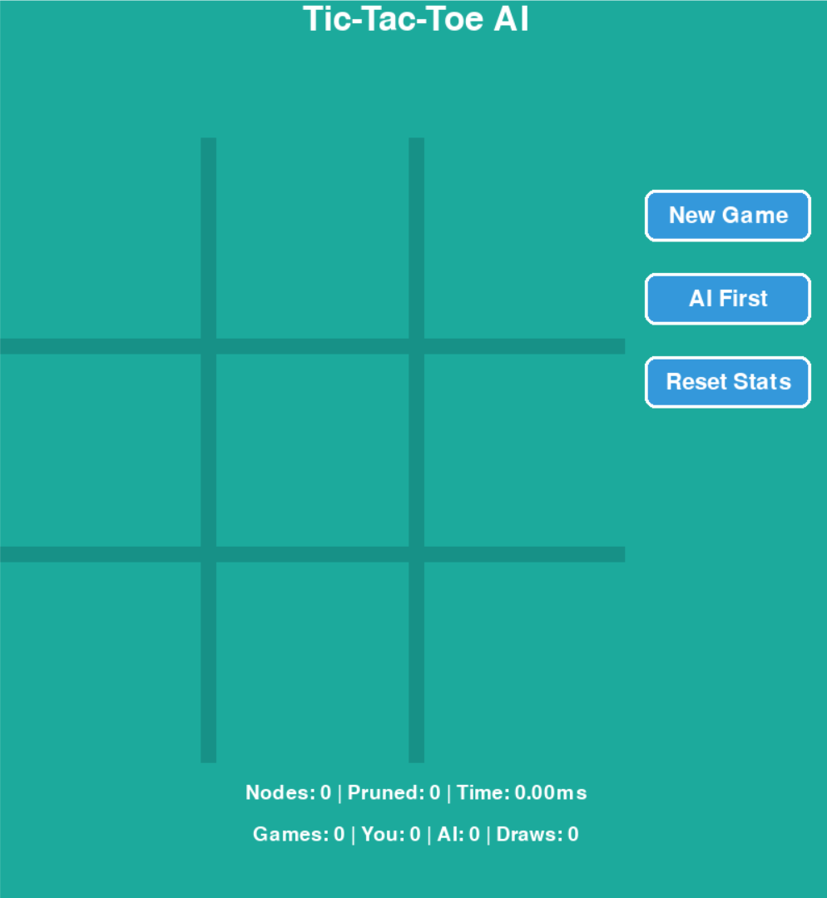
This Output shows the main graphical interface of the Tic-Tac-Toe game built using Pygame. The board consists of a 3×3 grid where the human player and the AI take turns placing O and X respectively. The design includes smooth borders, highlighted marks, and clear spacing to ensure good visibility. The interface also displays buttons such as New Game, AI First, and Reset Stats, allowing the user to control and restart gameplay. This serves as the base screen before or during match play.

Output 2: AI Winning Scenario
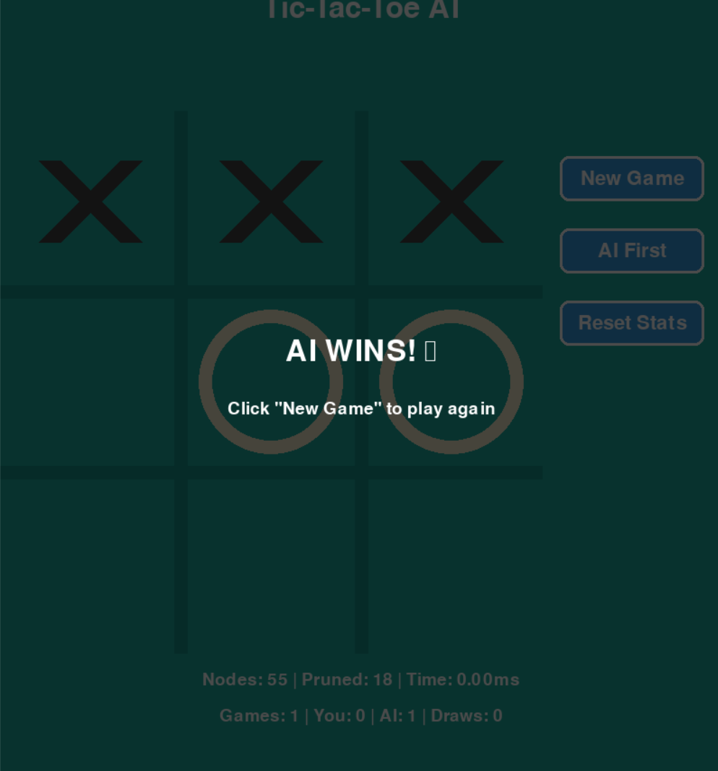
In this Output, the AI (X) wins the match. After analyzing all possible moves using the MiniMax algorithm with Alpha-Beta Pruning, the AI selects optimal moves to either win or ensure the opponent cannot win. Once a winning state is detected, the interface displays a highlighted message: “AI WINS! 🤖”, showing that the algorithm has successfully played strategically and achieved a victory. The board and result overlay confirm a flawless AI decision-making process.

Output 3: Draw Scenario
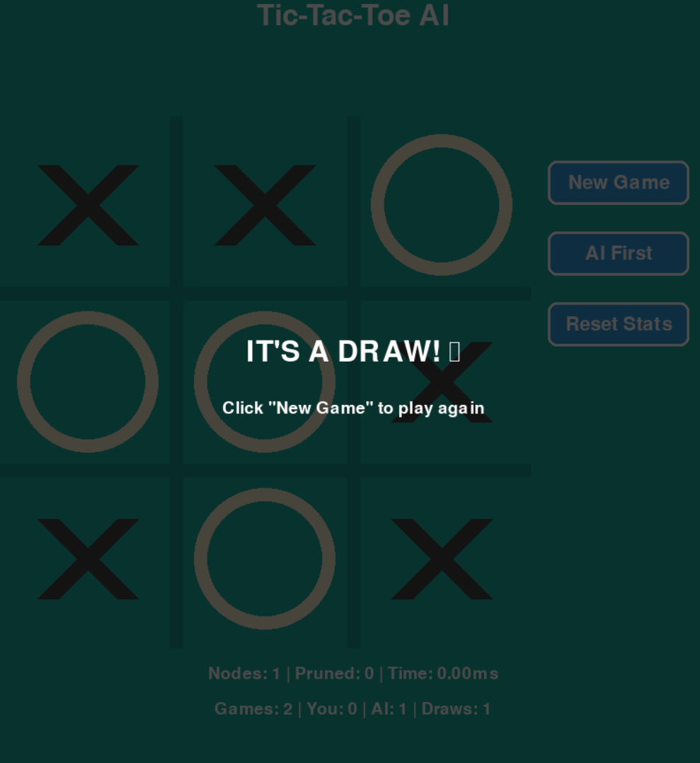
This screenshot shows a match that ends in a draw. Both the human and the AI have played optimally, resulting in no possible winning move for either side. The MiniMax algorithm ensures that the AI never loses when both players play perfectly, demonstrating correct implementation. A message “IT'S A DRAW! ” appears, indicating the game ended without a winner. This verifies the algorithm’s ability to identify and enforce draw situations.

Output 4: Search Nodes & Pruning Statistics
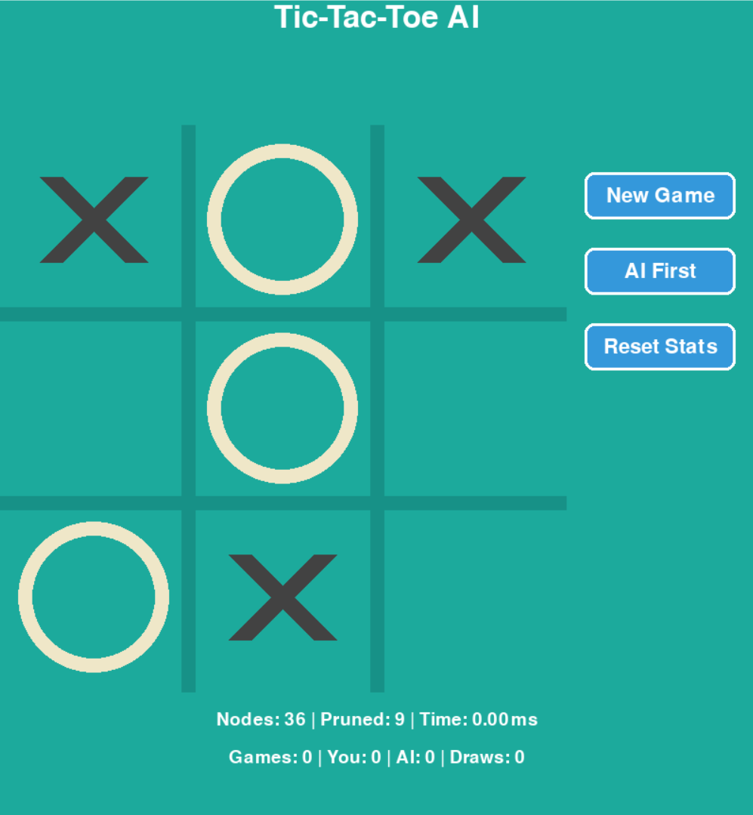
This output demonstrates the internal AI performance statistics, such as the number of nodes evaluated, nodes pruned, and computation time for generating the best move. These metrics highlight the efficiency of Alpha-Beta pruning, which eliminates unnecessary branches in the search tree to speed up decision-making. Displaying these values provides transparency in algorithm functioning and proves that the AI is working with optimized search logic.

RESULTS AND FUTURE ENHANCEMENT
• Successfully implemented intelligent Tic-Tac-Toe AI.
• MiniMax ensures optimal gameplay.
• Alpha-Beta pruning improves computation time.

• Future Enhancements:
- Multiplayer mode
- AI difficulty levels
- Heuristic learning and sound effects
Git Hub Link of the project and report

REFERENCES

📖 Books / E-Books
1️⃣ Artificial Intelligence: A Modern Approach
Stuart Russell & Peter Norvig
Prentice Hall, 3rd Edition
(Chapters on adversarial search, MiniMax, alpha-beta pruning)
2️⃣ Python Game Programming by Example
A. Shovic & M. Wiemer
Packt Publishing
(Reference for Pygame usage and game loop structure)
3️⃣ Artificial Intelligence (Sixth Edition)
Elaine Rich & Kevin Knight
McGraw-Hill
(Heuristic search & game-playing concepts)

🌐 Online Standard References
4️⃣ GeeksforGeeks — MiniMax Algorithm in Game Theory
https://www.geeksforgeeks.org/minimax-algorithm-in-game-theory-set-1-introduction/
(Concept explanation & algorithm pseudocode)
5️⃣ Pygame Official Documentation
https://www.pygame.org/docs/
(Reference for GUI development and event handling)

